Import a Map Source

You can import a Tableau Map Source (.tms) that someone has shared with you into a workbook, and then use it to create custom map views.

1. Select **Map** > **Background Maps** > **Map Services**. This opens the Map Services dialog box.
2. Click **Import**. This opens the Import Connection dialog box.
3. Navigate to the saved Tableau map source file (.tms) that you want to import, select it, and then click **Open**. This closes the Import Connection dialog box and adds the Tableau map source to the list of maps in the Map Services dialog box.

If you want to edit the newly added Tableau map source, select it from the list, and then click **Edit**. Otherwise, click **Close**to return to the view.

You can import as many Tableau map sources as you want into a workbook. Each Tableau map source you add appears as a background map in the **Background Maps** menu and is automatically selected as the default background map until another Tableau map source is imported, until you connect to a WMS server or Mapbox map, or until you select to use a different background map.

**Note:** When you create a new map view, the background map that is selected in the **Background Maps** menu is used to create the map for that view.

# Save a Map Source

After you add a Mapbox map or WMS server to your workbook, you can save it as a Tableau map source (.tms).

Saving a Mapbox map or WMS server as a Tableau Map Source allows you to share your map with others so they can quickly import it into their own workbooks and use it to create new map views. For more information about importing a Tableau Map Source into a workbook, see Import a Map Source.

1. Select **Map** > **Background Maps** > **Map Services**. This opens the Map Services dialog box.
2. Select the map that you want to save as a Tableau map source, and then click **Export**. This opens the Export Connection dialog box.
3. Type a name for the file, choose a location, and then click **Save**.

The Tableau map source includes any default map layer settings you have specified in the workbook. For example, the map source will include any custom set of map layers you have specified to show by default. For more information, see Customize How Your Map Looks in the Set Map Layers topic.

# Web Map Service (WMS) Servers

In Tableau Desktop, you can connect to map servers with the Web Map Service (WMS) protocol. WMS is a standard protocol for requesting and receiving geographically referenced imagery.

You can connect to any WMS server that supports the WMS 1.0.0, 1.1.0, or 1.1.1 standards.

**In this article**

* Connect to a WMS server in Tableau Desktop
* Use a WMS background map to build a map view in Tableau
* Save a WMS server as a Tableau map source
* Performance considerations for WMS servers in Tableau
* Supported Spatial Reference Systems for WMS servers

## Connect to a WMS server

1. In Tableau Desktop, select **Map** > **Background Maps** > **Map Services**.
2. In the Map Services dialog box, click **Add** > **WMS Servers**.
3. In the Add WMS Servers dialog box, type the URL for the server you want to connect to in Tableau, and then click **OK**.

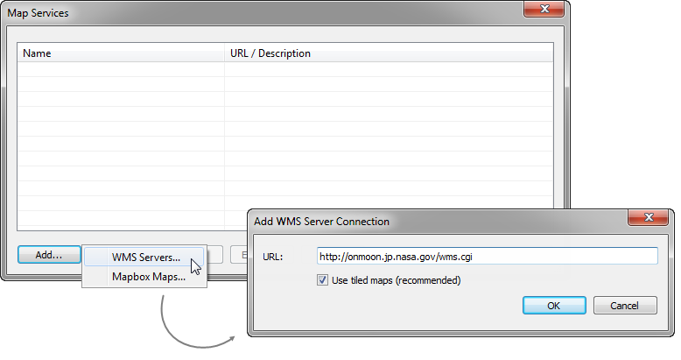

You can add as many map servers as you want to a workbook. Each WMS server you add appears as a background map in the **Background Maps** menu.

### Save a WMS server as a Tableau map source

After you add a WMS server to your workbook, it is saved with the workbook and available to anyone you share the workbook with. You can also save a WMS server as a Tableau Map Source (.tms) file, which you can share with others so they can quickly connect to it and use it in their own workbooks.

For more information about how to save a map as a Tableau map source, see Save a Map Source .

## Use a WMS background map

After you connect to a WMS server, you can create a map view using the WMS background map that Tableau creates.

**To create a map view using a WMS server:**

1. In Tableau Desktop, select **Map**> **Background Maps**, and then select a WMS background map to use in the view.

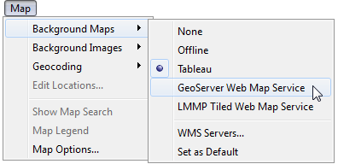

1. Add a geographic field to the view.

For more information, see Mapping Concepts in Tableau.

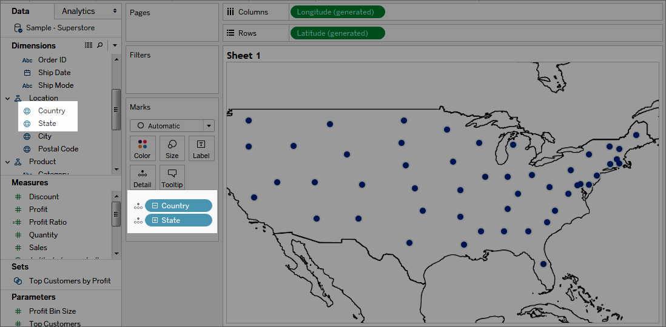

1. Select **Map**> **Map Layers**, and then select the map layers you want to show in the view.

For more information, see Customize How Your Map Looks.

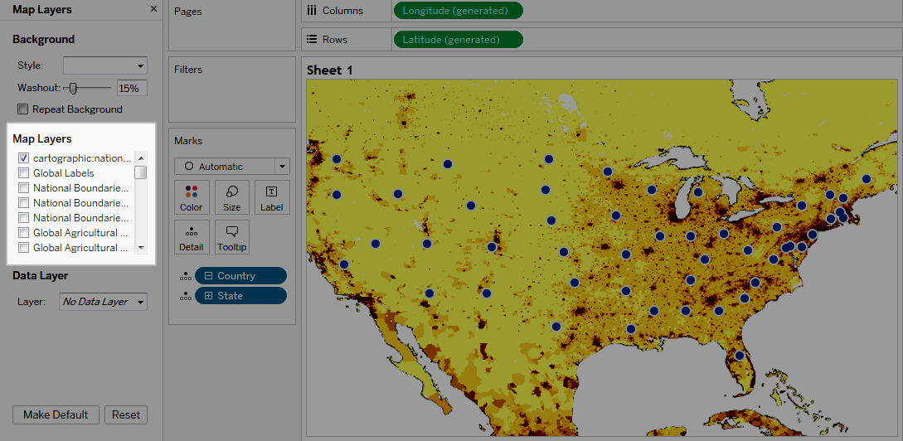

## Performance considerations

The content, speed, and performance of a WMS server is reliant on the network and WMS provider. If your Internet connection is interrupted or if you're working behind a restrictive firewall, you can use the Offline background map that comes installed with Tableau Desktop to avoid any performance issues while you build your map view. You can switch back to your WMS server at any time.